**GEETHANJALI COLLEGE OF ENGINEERING AND TECHNOLOGY**

Project submitted in fulfilment of the requirement for Property Tax Management of the Rampally Dayara village



**Department of Computer Science and Engineering**

**Accredited by NBA**

**Geethanjali College of Engineering and Technology**

**(UGC Autonomous)**

(Affiliated to J.N.T.U.H, Approved by AICTE, New Delhi) Cheeryal (V), Keesara (M), Medchal.Dist.-501 301.

**February 2023**

Geethanjali College of Engineering & Technology

### (UGC Autonomous)

(Affiliated to JNTUH, Approved by AICTE, New Delhi) Cheeryal (V), Keesara(M), Medchal Dist.-501 301.



### Department of Computer Science and Engineering in association with NSS

### Developed project on

### RAMPALLY DAYARA PROPERTY TAX MANAGEMENT

**Sanctioned by UBA**

**2022-23**

### NSS Program Officer Faculty Coordinators

Dr. R. Odaiah Mrs. S. Radha

Mr. Y. Siva

**Students involved in the project:**

1. P. Haneesh Reddy – CSE – 18R11A05P8
2. K. Ravi Kumar – CSE – 19R11A0520
3. N.Rohan Kausik – CSE – 19R11A0581
4. Vinay Reddy – CSE – 19R11A05B5
5. P. Badrinath Reddy – CSE – 19R11A05C9
6. P. Jahnavi – CSE – 19R11A05D0
7. Gyaneshwar – CSE – 20R15A0512
8. Nithin – CSE – 20R15A0516

Proposal By**:**

**GEETHANJALI COLLEGE OF ENGINEERING AND TECHNOLOGY, CHEERYAL**

Title of the Project**:**

**Rampally Dayara Property Tax Management**

Village where it is to be implemented**:**

**RAMPALLY DAYARA, KEESARA (M)-501301, MEDCHAL(DT), TELANGANA.**

Why this technology required:

**The village panchayat is facing problem with the tax payments. As physical records are maintained, it is very difficult for the management to keep track of all the details of taxpayers and the amount paid by them. The taxpayers may manipulate the amount that need to be paid. This creates complexity for both management of the panchayat and innocent people.**

Total cost of the project:

Requirements Estimated Cost

**Bluehost (With Website Backup, SEO Tools, SSL**

**Certificate) Rs. 13032**

**SMS Bundle (Text local) - 10000 messages Rs. 3500**

**Backup for the cloud Rs. 5000**

**System Charges Rs. 35000**

**Miscellaneous Expenses Rs. 2000**

**Total Rs. 58532**

Funds raised from gram panchayat or CSR or district/local administration? **N/A**

Details of the funds raised from other agencies: **N/A**

Execution of the project along with role of all participating stakeholders:

Proposed Solution:

**To reduce all these complexities, we came up with the idea of maintaining the records in a website.**

Description:

**The website would be helpful for maintaining the information of the taxpayers who paid the amount and the amount they need to pay later. When villagers pay the tax, our application sends direct message to the taxpayers containing the details of the payment and the balance amount need to be paid. It also sends messages to the people who did not pay the tax with amount and deadline.**

**We will store all these details in a cloud/local server depending on the requirement. Full access will be given to the admin (panchayat) for adding or deleting the records of plots when people sell their plots. There will be an operator who has access to enter the details of payments of that day into the database.**

**The admin and the operator will be given the authentication details based on the role.**

**So, by this we can avoid frauds and provide security to the information. Also, the application will be up to date according to the government norms.**

Technologies:

**o MySql**

**o Node.js**

**o Express.js**

**o React.js**

Duration of the work:

**6 Months.**

Impact of this work on learning of students/teachers:

**There will be a constant automated check on the property tax of all the properties in the village. This can prevent misconceptions regarding the payments and reduce the manipulation of the records. Every villager receives an acknowledgement regarding their payment. In a single click, we can get total amount collected on that particular**

**day and the pending amount to be paid by the taxpayers.**

Role of stakeholders in maintaining sustainability after the project duration:

**We will provide technical and maintenance support.**

Role of PI after completion of the project duration:

**Constant guidance and monitoring will be provided.**

Process of execution of the project:

**o Learning or intern phase.**

**o Database design and Frontend layout design (Buying SMS server or gateway).**

**o Front end development.**

**o Backend development (Providing connection between backend API and frontend API).**

**o Communication between react and node (Local Deployment).**

**o Push to ngrok for local host (https://ngrok.com/)**

**o Node cloud hosting platform.**

**o Finding MySql hosting platform.**

**o Deploy backend on the cloud.**

**o Testing and debugging.**

PHOTOS:

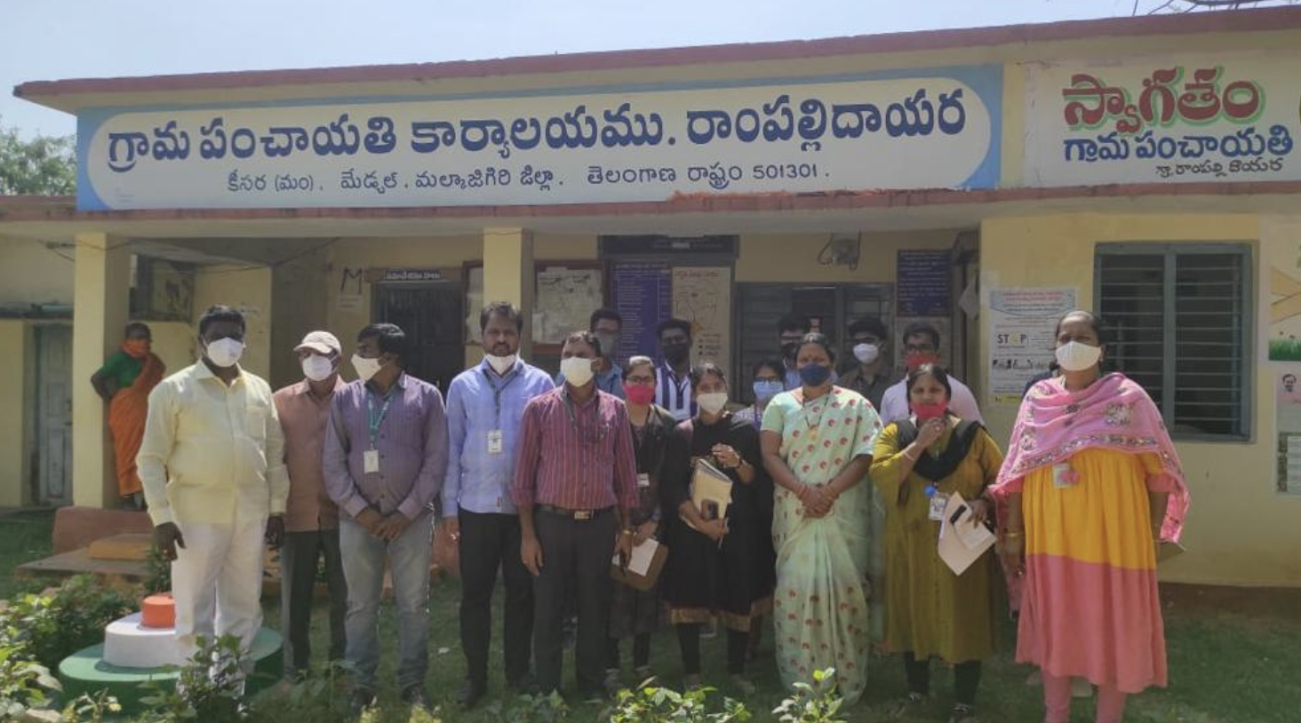

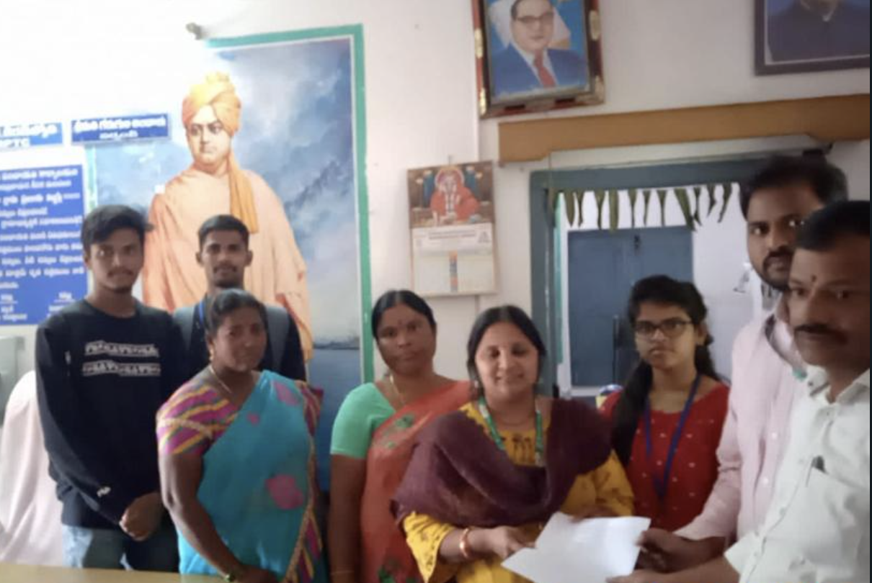

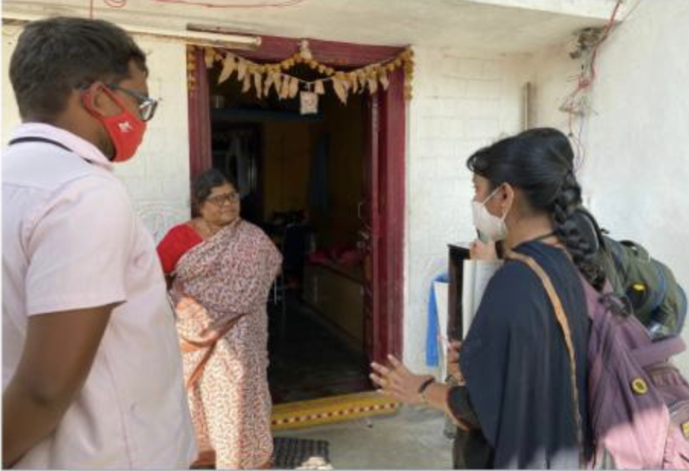

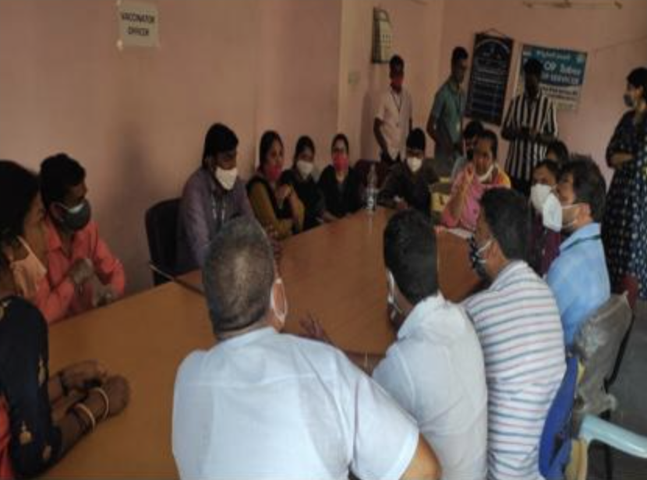

UBA SEG Grants



**Sanction Letter**





**Funding Data:**

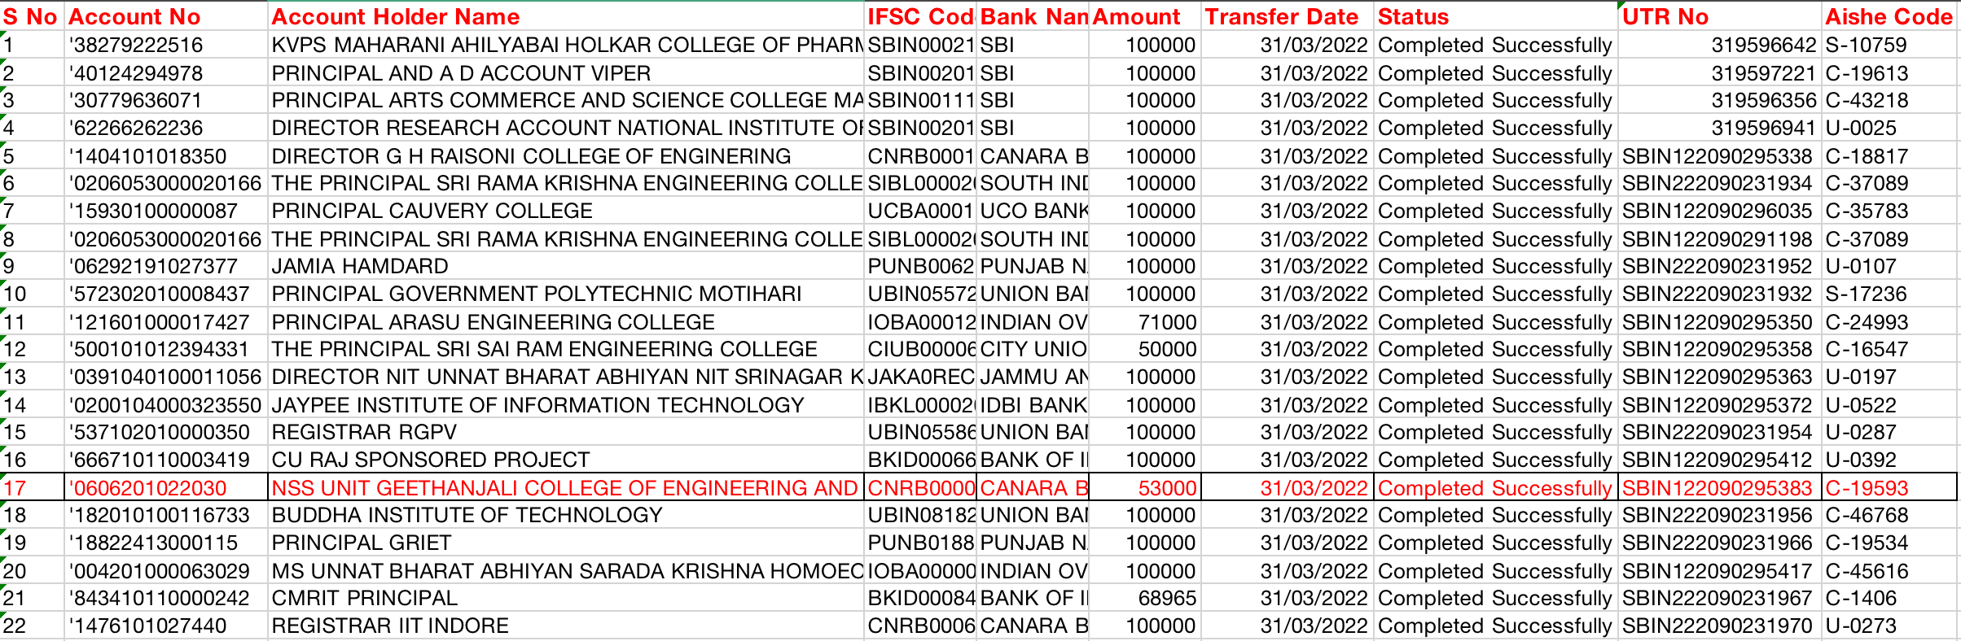

**Village Letter:**



# LIST OF FIGURES/DIAGRAMS/GRAPHS

**Name Page No**

* + 1. Use Case Diagram 6
    2. Class Diagram 7
    3. Sequence Diagram 7
    4. Activity Diagram 8
  1. Home page 25
  2. Dashboard 25
  3. Login Page 28
  4. Send tax bill to users 30
  5. Send customize message to users 28
  6. Add new users 26
  7. View and delete the users 30
  8. Update payment information 29
  9. Data filter 26

7.10 Filter by name 27

7.11 Profile details 29

**TABLE OF CONTENTS**

|  |  |  |
| --- | --- | --- |
| **CHAPTER NO.** | **TITLE** | **PAGE NO.** |
|  | **Proposal** | v |
|  | **UBA SEG Grants** | vi |
|  | **Sanction Letter** | viii |
|  | **Funding Data** | x |
|  | **Village Letter** | x |
|  | **List of Figures/Screenshots/Diagrams** | xi |
| **1.** | **INTRODUCTION** | 1 |
| **2.** | **SYSTEM ANALYSIS** | 2 |
| **3.** | **LITERATURE SURVEY** | 4 |
| **4.** | **DESIGN** | 5 |
| **5.** | **CODING** | 9 |
| **6.** | **TESTING** | 22 |
| **7.** | **OUTPUT SCREENS** | 25 |
| **8.** | **CONCLUSION** | 31 |
| **9.** | **BIBLIOGRAPHY** | 32 |
| **10.** | **APPENDIX** | 33 |

# 1. INTRODUCTION

## 1.1 Objective:

The village panchayat is facing problems with tax payments. As physical records are maintained, it is very difficult for the management to keep track of all the details of taxpayers and the amount paid by them. The taxpayers may manipulate the amount that needs to be paid. This creates complexity for both management of the panchayat and innocent people.

The main objective of the project is to develop a Web application on the “Rampally Dayara Property Tax Management System”. This web app maintains tariff records and keeps the public informed. The Sanctioned Project will be given to “Rampally Dayara Village” as part of the UBA Scheme.

## 1.2 Description:

The Rampally Dayara Village Panchayat is facing a problem with the property tax assessment. The physical records to be maintained are enormous and it has been tedious for the management to keep track of all the details of taxpayers and their taxes as the result the transparency between the villagers and the village panchayat is declining at an alarming rate.

The website would be helpful for maintaining the information of the taxpayers who paid the amount and the amount they need to pay later. The proposed solution will avoid fraud and provide security to the information. Also, the application will be up to date according to government norms.

We stored all the details of the families who are owning land in the village in a database. We also stored the amount of tax that should be paid by the landowners with tax percentages in the database itself along with the details. When a person pays the amount, the computer operator should update the value in the application. These changes will be stored in the database. When a new person registers land, then his/her details must be added to the application. Similarly, when a person sells his property, those details must be deleted from the database by the computer operator A text message will be sent to all the taxpayers when they pay taxes yearly once. Panchayat can also send the latest updates through this application to all the villagers.

# 2. SYSTEM ANALYSIS

## 2.1 Existing System:

## In the village of Rampally Dayara, all the tax payment records are maintained manually by the panchayath. The village panchayat is facing problems with tax payments. As physical records are maintained, it is very difficult for the management to keep track of all the details of taxpayers and the amount paid by them. The taxpayers may manipulate the amount that needs to be paid. This creates complexity for both management of the panchayat and innocent people.

## 2.2 Proposed System:

## To avoid all the aforementioned problems, we, the NSS team, proposed a method of maintaining the data on a website. This website would be helpful for maintaining the information of the taxpayers who paid the amount and the amount they need to pay later. The proposed solution will avoid fraud and provide security to the information. Also, the application will be up to date according to government norms and will satisfy the requirements of both the government of Rampally as well as the taxpayers.

## 2.3 Modules:

## 

## A system analysis for a tax management system would involve identifying the goals and requirements of the system, as well as evaluating its design, implementation, and performance. The following steps would typically be involved in a system analysis for a tax management system:

## Requirements gathering: This involves identifying the functional and non-functional requirements of the tax management system. The functional requirements would include features such as tax calculation, tax filing, and tax payment, while the non-functional requirements would include things like performance, security, and user-friendliness.

## Business process analysis: This involves mapping out the existing tax management process, including the flow of information and the roles and responsibilities of different stakeholders. This information would then be used to design the tax management system to meet the business requirements.

## System design: This involves creating a detailed design of the tax management system, including the architecture, database schema, user interface, and algorithms for tax calculation and payment. The design should also consider how the system will integrate with other systems, such as accounting and payroll systems.

## Implementation and testing: This involves building the tax management system and conducting a thorough testing phase to ensure that it meets the requirements and works as expected.

## User acceptance testing: This involves allowing the users of the tax management system to test it and provide feedback on its performance, functionality, and usability.

## Deployment and maintenance: This involves deploying the tax management system and providing ongoing support and maintenance to ensure its continued performance and functionality.

## Throughout the system analysis process, it is important to consider the legal and regulatory requirements for tax management, as well as the security and privacy needs of the business and its customers. A tax management system should also be designed to be scalable and flexible, so that it can adapt to changes in the business and the tax laws.

## 2.4 System Configuration

## Hardware Requirements:

## Processor: Intel Core i3 and above

## RAM: 4GB

## Hard Disk: 10GB

## Software Requirements:

## Operating System: Windows 7 or later, macOS and Linus.

## Front End: HTML, CSS, Java Script

## Back End: PHP, MYSQL and other external API’s.

# 3. LITERATURE SURVEY

We the team of NSS went to villages under the scheme Unnat Bharath Yojana to find out their problems and find solutions in a modern way. Under this, we went to Rampally Dayara village panchayat and surveyed the people who live there. Panchayat management and the villagers said they are facing issues with manual property tax management. So, we the team of NSS from GCET proposed an online property tax management system which can keep track of all the payments, and updates and avoid fraud.

**Methodology of the proposed system acquired as part of the literature survey:**

* Villagers visit the panchayat and pay their taxes.
* The operator enters their transaction into the portal; the application stores the transaction

into the database.

* They receive immediate confirmation of the amount that they’ve paid and their due if any.
* After the end of each day, the commerce of that day is sent to the sarpanch of the village

totally out the cash register the next morning.

* The whole “Rampally Dayara village” community participates in this system which

increases the total number of regular taxpayers in that locality.

# 4. SYSTEM DESIGN

## 4.1 System Architecture:

A system architecture is a [conceptual model](https://en.wikipedia.org/wiki/Conceptual_model) that defines the [structure,](https://en.wikipedia.org/wiki/Structure)behaviour[,](https://en.wikipedia.org/wiki/Behavior) and [views](https://en.wikipedia.org/wiki/View_model) of a [system.](https://en.wikipedia.org/wiki/System) An architecture description is a formal description and representation of a system, organized in a way that supports reasoning about the [structures](https://en.wikipedia.org/wiki/Structure) and [behaviours](https://en.wikipedia.org/wiki/Behavior) of the system.

The architecture pertaining to our solution is as follows:

**UML Diagrams:**

***Actor:*** A coherent set of roles that users of use cases play when interacting with the use cases.



***Use case:*** A description of sequence of actions, including variants, that a system performs that yields an observable result of value of an actor.

UML stands for Unified Modelling Language. UML is a language for specifying, visualizing and documenting the system. This is the step while developing any product after analysis. The goal from this is to produce a model of the entities involved in the project which later need to be built. The representation of the entities that are to be used in the product being developed need to be designed.

## Fig: USE CASE Diagram

## 

## Fig: CLASS Diagram

## 

## Fig: SEQUENCE Diagram

## 

## Fig: ACTIVITY Diagram

## 

# 5. CODING

## Home.php:

## <?php

## session_start();

## if(!isset($_SESSION["name"])) {

## header("Location:index.php");

## }

## @include 'config.php';

## ?>

## <!DOCTYPE html>

## <html lang="en">

## <head>

## <meta charset="utf-8">

## <meta content="width=device-width, initial-scale=1.0" name="viewport">

## <meta content="" name="description">

## <meta content="" name="keywords">

## 

## <!-- Favicons -->

## <title>Property Rampally Dhayara Village</title>

## 

## <link href="assets/img/main.jpg" rel="icon">

## <!-- Google Fonts -->

## <link href="https://fonts.gstatic.com" rel="preconnect">

## <link href="https://fonts.googleapis.com/css?family=Open+Sans:300,300i,400,400i,600,600i,700,700i|Nunito:300,300i,400,400i,600,600i,700,700i|Poppins:300,300i,400,400i,500,500i,600,600i,700,700i" rel="stylesheet">

## <!-- Vendor CSS Files -->

## <link href="assets/vendor/bootstrap/css/bootstrap.min.css" rel="stylesheet">

## <link href="assets/vendor/bootstrap-icons/bootstrap-icons.css" rel="stylesheet">

## <link href="assets/vendor/boxicons/css/boxicons.min.css" rel="stylesheet">

## <link href="assets/vendor/quill/quill.snow.css" rel="stylesheet">

## <link href="assets/vendor/quill/quill.bubble.css" rel="stylesheet">

## <link href="assets/vendor/remixicon/remixicon.css" rel="stylesheet">

## <link href="assets/vendor/simple-datatables/style.css" rel="stylesheet">

## <!-- Template Main CSS File -->

## <link href="assets/css/style.css" rel="stylesheet">

## <!-- =======================================================

## * Template Name: NiceAdmin - v2.4.0

## * Template URL: https://bootstrapmade.com/nice-admin-bootstrap-admin-html-template/

## * Author: BootstrapMade.com

## * License: https://bootstrapmade.com/license/

## ======================================================== -->

## </head>

## <body>

## <!-- ======= Header ======= class="logo d-flex align-items-center" -->

## <header id="header" class="header fixed-top d-flex align-items-center">

## <i class="bi bi-list toggle-sidebar-btn"></i>

## &nbsp;

## <div id="photo" style="text-align: center">

## <img style="vertical-align:middle" src="assets/img/main.jpg" width="40px" alt="">

## <span style="vertical-align:middle; font-size: 20px; font-weight: 700; color: orange; ">Rampally Dayara Village</span>

## </div>

## <style>/*<![CDATA[*/

## #google_translate_element{}

## .goog-te-banner-frame.skiptranslate,.goog-te-gadget-simple img,img.goog-te-gadget-icon,.goog-te-menu-value span{display:none!important}

## .goog-te-menu-frame{box-shadow:none!important}

## .goog-te-gadget-simple{background-color:transparent!important;background:url("data:image/svg+xml,%3Csvg viewBox='0 0 24 24' xmlns='http://www.w3.org/2000/svg'%3E%3Cpath d='M20,5H10.88L10,2H4A2,2 0 0,0 2,4V17A2,2 0 0,0 4,19H11L12,22H20A2,2 0 0,0 22,20V7A2,2 0 0,0 20,5M7.17,14.59A4.09,4.09 0 0,1 3.08,10.5A4.09,4.09 0 0,1 7.17,6.41C8.21,6.41 9.16,6.78 9.91,7.5L10,7.54L8.75,8.72L8.69,8.67C8.4,8.4 7.91,8.08 7.17,8.08C5.86,8.08 4.79,9.17 4.79,10.5C4.79,11.83 5.86,12.92 7.17,12.92C8.54,12.92 9.13,12.05 9.29,11.46H7.08V9.91H11.03L11.04,10C11.08,10.19 11.09,10.38 11.09,10.59C11.09,12.94 9.5,14.59 7.17,14.59M13.2,12.88C13.53,13.5 13.94,14.06 14.39,14.58L13.85,15.11L13.2,12.88M13.97,12.12H13L12.67,11.08H16.66C16.66,11.08 16.32,12.39 15.1,13.82C14.58,13.2 14.21,12.59 13.97,12.12M21,20A1,1 0 0,1 20,21H13L15,19L14.19,16.23L15.11,15.31L17.79,18L18.5,17.27L15.81,14.59C16.71,13.56 17.41,12.34 17.73,11.08H19V10.04H15.36V9H14.32V10.04H12.36L11.18,6H20A1,1 0 0,1 21,7V20Z' fill='%23161617'/%3E%3C/svg%3E") center / 12px no-repeat;-webkit-transition:all .2s ease;transition:all .2s ease;background-size: 20px 20px;display:inline-block;font-weight:400;line-height: 1.8;padding:0 6px;text-align:center;white-space:nowrap;vertical-align: middle;-ms-touch-action: manipulation;touch-action:manipulation;cursor:pointer;-webkit-user-select: none;-moz-user-select:none;-ms-user-select:none;user-select:none;border-left:none!important;border-top:none!important;border-bottom:none!important;border-right:none!important;border-radius: 4px}

## /*]]>*/</style>

## <nav class="header-nav ms-auto">

## <ul class="d-flex align-items-center">

## <a class="nav-link nav-icon" href="#" data-bs-toggle="dropdown">

## <div id="google_translate_element"></div>

## 

## </a>

## <!-- <div id="google_translate_element"></div> -->

## <script>

## function googleTranslateElementInit() {

## new google.translate.TranslateElement(

## {

## includedLanguages: 'en,te,hi',

## pageLanguage: 'en',

## layout: google.translate.TranslateElement.FloatPosition.TOP_RIGHT

## },

## 'google_translate_element'

## );

## }

## </script>

## <script src="http://translate.google.com/translate_a/element.js?cb=googleTranslateElementInit"></script>

## 

## 

## <style>/<![CDATA[/

## #google_translate_element{}

## .goog-te-banner-frame.skiptranslate,.goog-te-gadget-simple img,img.goog-te-gadget-icon,.goog-te-menu-value span{display:none!important}

## .goog-te-menu-frame{box-shadow:none!important}

## .goog-te-gadget-simple{background-color:transparent!important;background:url("data:image/svg+xml,%3Csvg viewBox='0 0 24 24' xmlns='http://www.w3.org/2000/svg'%3E%3Cpath d='M20,5H10.88L10,2H4A2,2 0 0,0 2,4V17A2,2 0 0,0 4,19H11L12,22H20A2,2 0 0,0 22,20V7A2,2 0 0,0 20,5M7.17,14.59A4.09,4.09 0 0,1 3.08,10.5A4.09,4.09 0 0,1 7.17,6.41C8.21,6.41 9.16,6.78 9.91,7.5L10,7.54L8.75,8.72L8.69,8.67C8.4,8.4 7.91,8.08 7.17,8.08C5.86,8.08 4.79,9.17 4.79,10.5C4.79,11.83 5.86,12.92 7.17,12.92C8.54,12.92 9.13,12.05 9.29,11.46H7.08V9.91H11.03L11.04,10C11.08,10.19 11.09,10.38 11.09,10.59C11.09,12.94 9.5,14.59 7.17,14.59M13.2,12.88C13.53,13.5 13.94,14.06 14.39,14.58L13.85,15.11L13.2,12.88M13.97,12.12H13L12.67,11.08H16.66C16.66,11.08 16.32,12.39 15.1,13.82C14.58,13.2 14.21,12.59 13.97,12.12M21,20A1,1 0 0,1 20,21H13L15,19L14.19,16.23L15.11,15.31L17.79,18L18.5,17.27L15.81,14.59C16.71,13.56 17.41,12.34 17.73,11.08H19V10.04H15.36V9H14.32V10.04H12.36L11.18,6H20A1,1 0 0,1 21,7V20Z' fill='%23161617'/%3E%3C/svg%3E") center / 12px no-repeat;-webkit-transition:all .2s ease;transition:all .2s ease;background-size: 20px 20px;display:inline-block;font-weight:400;line-height: 1.8;padding:0 6px;text-align:center;white-space:nowrap;vertical-align: middle;-ms-touch-action: manipulation;touch-action:manipulation;cursor:pointer;-webkit-user-select: none;-moz-user-select:none;-ms-user-select:none;user-select:none;border-left:none!important;border-top:none!important;border-bottom:none!important;border-right:none!important;border-radius: 4px}

## /]]>/</style>

## <nav class="header-nav ms-auto">

## <ul class="d-flex align-items-center">

## <a class="nav-link nav-icon" href="#" data-bs-toggle="dropdown">

## <div id="google_translate_element"></div>

## 

## </a>

## <!-- <div id="google_translate_element"></div> -->

## <script>

## function googleTranslateElementInit() {

## new google.translate.TranslateElement(

## {

## includedLanguages: 'en,te,hi',

## pageLanguage: 'en',

## layout: google.translate.TranslateElement.FloatPosition.TOP_RIGHT

## },

## 'google_translate_element'

## );

## }

## </script>

## <script src="http://translate.google.com/translate_a/element.js?cb=googleTranslateElementInit"></script>

## 

## 

## <li class="nav-item dropdown pe-3">

## <a class="nav-link nav-profile d-flex align-items-center pe-0" href="#" data-bs-toggle="dropdown">

## <img src="assets/img/user.svg" width="35px" alt="Profile" class="rounded-circle">

## <span class="d-none d-md-block dropdown-toggle ps-2"><?php echo $_SESSION["name"]; ?></span>

## </a><!-- End Profile Iamge Icon -->

## <ul class="dropdown-menu dropdown-menu-end dropdown-menu-arrow profile">

## <li class="dropdown-header">

## <h6><?php echo $_SESSION["name"]; ?></h6>

## <span></span>

## </li>

## <li>

## <hr class="dropdown-divider">

## </li>

## 

## <li>

## <hr class="dropdown-divider">

## </li>

## <li>

## <a class="dropdown-item d-flex align-items-center" href="contact.php">

## <i class="bi bi-question-circle"></i>

## <span>Need Help?</span>

## </a>

## </li>

## <li>

## <hr class="dropdown-divider">

## </li>

## <li>

## <a class="dropdown-item d-flex align-items-center" href="logout.php">

## <i class="bi bi-box-arrow-right"></i>

## <span>Sign Out</span>

## </a>

## </li>

## </ul><!-- End Profile Dropdown Items -->

## </li><!-- End Profile Nav -->

## </ul>

## </nav><!-- End Icons Navigation -->

## </header><!-- End Header -->

## <!-- ======= Sidebar ======= -->

## <aside id="sidebar" class="sidebar">

## <ul class="sidebar-nav" id="sidebar-nav">

## <li class="nav-item">

## <a class="nav-link " href="home.php">

## <i class="bi bi-grid"></i>

## <span>Dashboard</span>

## </a>

## </li><!-- End Dashboard Nav -->

## <li class="nav-item">

## <a class="nav-link collapsed" data-bs-target="#components-nav" data-bs-toggle="collapse" href="#">

## <i class="bi bi-layout-text-window"></i><span>Messages</span><i class="bi bi-chevron-down ms-auto"></i>

## </a>

## <ul id="components-nav" class="nav-content collapse " data-bs-parent="#sidebar-nav">

## <li>

## <a href="sendtax1.php">

## <i class="bi bi-circle"></i><span>Send Tax</span>

## </a>

## </li>

## <li>

## <a href="customtax.php">

## <i class="bi bi-circle"></i><span>Custom Messages</span>

## </a>

## </li>

## </ul>

## </li><!-- End Components Nav -->

## <li class="nav-item">

## <a class="nav-link collapsed" data-bs-target="#forms-nav" data-bs-toggle="collapse" href="#">

## <i class="bi bi-menu-button-wide"></i><span>Manage Users</span><i class="bi bi-chevron-down ms-auto"></i>

## </a>

## <ul id="forms-nav" class="nav-content collapse " data-bs-parent="#sidebar-nav">

## <li>

## <a href="adduser.php" >

## <i class="bi bi-circle"></i><span>Add User</span>

## </a>

## </li>

## <li>

## <a href="deleteuser.php">

## <i class="bi bi-circle"></i><span>Delete User</span>

## </a>

## </li>

## <li>

## <!-- <a <?php

## include("updatestaus.php")

## ?> -->

## <a href="updatestatus.php">

## <i class="bi bi-circle"></i><span>Update Status</span>

## </a>

## </li>

## </ul>

## </li><!-- End Forms Nav -->

## <li class="nav-item">

## <a class="nav-link collapsed" data-bs-target="#tables-nav" data-bs-toggle="collapse" href="#">

## <i class="bi bi-bar-chart"></i><span>Analyse Data</span><i class="bi bi-chevron-down ms-auto"></i>

## </a>

## <ul id="tables-nav" class="nav-content collapse " data-bs-parent="#sidebar-nav">

## <li>

## <a href="datafilter.php">

## <i class="bi bi-circle"></i><span>Data Filter</span>

## </a>

## </li>

## <li>

## <a href="filterbyname.php">

## <i class="bi bi-circle"></i><span>Filter By House Number</span>

## </a>

## </li>

## </ul>

## </li>

## <!-- End Tables Nav -->

## </ul>

## </aside><!-- End Sidebar-->

## <main id="main" class="main">

## <div class="pagetitle">

## <h1>Dashboard</h1>

## <nav>

## <ol class="breadcrumb">

## <li class="breadcrumb-item"><a href="home.php">Home</a></li>

## <li class="breadcrumb-item active">Dashboard</li>

## </ol>

## </nav>

## </div><!-- End Page Title -->

## <section class="section dashboard">

## <div class="row">

## <!-- Left side columns -->

## <div class="col-lg-12">

## <div class="row">

## 

## <!-- Revenue Card -->

## <div class="col-xxl-4 col-md-6">

## <div class="card info-card revenue-card">

## <!-- <div class="filter">

## <a class="icon" href="#" data-bs-toggle="dropdown"><i class="bi bi-three-dots"></i></a>

## <ul class="dropdown-menu dropdown-menu-end dropdown-menu-arrow">

## <li class="dropdown-header text-start">

## <h6>Filter</h6>

## </li>

## <li><a class="dropdown-item" href="#">Today</a></li>

## <li><a class="dropdown-item" href="#">This Month</a></li>

## <li><a class="dropdown-item" href="#">This Year</a></li>

## </ul>

## </div> -->

## <?php

## @include 'config.php';

## date_default_timezone_set('Asia/Kolkata');

## $year1 = date('Y');

## $month1 = date('m');

## $date1 = 1;

## $date2=1;

## $year2=null;

## $month2=null;

## $day2=null;

## if($month1=="12"){

## $month2=1;

## $year2=$year1+1;

## $day2=1;

## }else{

## $month2=$month1+1;

## $year2=$year1;

## $date2=$date1;

## }

## $d1=$year1."-".$month1."-".$date1;

## $d2=$year2."-".$month2."-".$date2;

## $que = "SELECT Total FROM transcation WHERE Pay_date BETWEEN '$d1' AND '$d2';";

## $que1 = "SELECT DISTINCT(House_number) FROM transcation WHERE Pay_date BETWEEN '$d1' AND '$d2';";

## 

## $rec=mysqli_query($con,$que);

## $rec1 = mysqli_query($con,$que1);

## $number_of_villagers_paid=mysqli_num_rows($rec1);

## $amount_collected=0;

## if(mysqli_num_rows($rec)>0){

## while($row = mysqli_fetch_assoc($rec)){

## $amount_collected+=$row['Total'];

## }

## }

## $user=$_SESSION["name"];

## $query1 = "select * from login where Username='$user' ";

## $result = mysqli_query($con,$query1);

## 

## if($result){

## if(mysqli_num_rows($result)>0)

## {

## while($row1 = mysqli_fetch_assoc($result)) {

## $year=$row1["Year"];

## $curyear=date('Y');

## if($year!=$curyear){

## $que = "select * from arrears;";

## $result1 = mysqli_query($con,$que);

## if(mysqli_num_rows($result1)>0)

## {

## while($row = mysqli_fetch_assoc($result1)) {

## $House_number = $row["House_number"];

## $original_current = $row["Current"];

## $new_arrear=$row["Arrears"]+$original_current;

## $new_total = $new_arrear+$original_current;

## $que2 = "update arrears set Arrears='$new_arrear',Current = '$original_current',Total ='$new_total' where House_number='$House_number' ";

## $record2 = mysqli_query($con,$que2);

## 

## }

## }

## $que3 = "update login set Year = '$curyear' where Username='$user' ";

## $result2 = mysqli_query($con,$que3);

## }

## break;

## }

## 

## }

## }

## 

## 

## ?>

## <div class="card-body">

## <h5 class="card-title">Amount collected <span>| This Month</span></h5>

## <div class="d-flex align-items-center">

## <div class="card-icon rounded-circle d-flex align-items-center justify-content-center">

## <i class="bi bi-currency-rupee"></i>

## </div>

## <div class="ps-3">

## <h6><?php echo $amount_collected; ?></h6>

## <span class="text-success small pt-1 fw-bold"><?php echo $number_of_villagers_paid; ?></span> <span class="text-muted small pt-2 ps-1">members paid</span>

## </div>

## </div>

## </div>

## </div>

## </div><!-- End Revenue Card -->

## <!-- Customers Card -->

## <div class="col-xxl-4 col-xl-6">

## <div class="card info-card customers-card">

## <!-- <div class="filter">

## <a class="icon" href="#" data-bs-toggle="dropdown"><i class="bi bi-three-dots"></i></a>

## <ul class="dropdown-menu dropdown-menu-end dropdown-menu-arrow">

## <li class="dropdown-header text-start">

## <h6>Filter</h6>

## </li>

## <li><a class="dropdown-item" href="#">Today</a></li>

## <li><a class="dropdown-item" href="#">This Month</a></li>

## <li><a class="dropdown-item" href="#">This Year</a></li>

## </ul>

## </div> -->

## <?php

## @include 'config.php';

## $query="select * from main ;";

## $record=mysqli_query($con,$query);

## $res=mysqli_num_rows($record);

## 

## ?>

## <div class="card-body">

## <h5 class="card-title">Villagers <span>| of Dayara</span></h5>

## <div class="d-flex align-items-center">

## <div class="card-icon rounded-circle d-flex align-items-center justify-content-center">

## <i class="bi bi-people"></i>

## </div>

## <div class="ps-3">

## <h6><?php echo $res; ?></h6>

## <span class="text-danger small pt-1 fw-bold"></span> <span class="text-muted small pt-2 ps-1"></span>

## </div>

## </div>

## </div>

## </div>

## </div><!-- End Customers Card -->

## 

## <div class="pagetitle">

## <h1>Gallery</h1>

## </div><!-- End Page Title -->

## <div class="col-lg-10">

## <div class="card">

## <div class="card-body">

## <h5 class="card-title">Gram Panchayath Rampally Dayara Village</h5>

## 

## <!-- Slides with controls -->

## <div id="carouselExampleControls" class="carousel slide" data-bs-ride="carousel">

## <div class="carousel-inner">

## <div class="carousel-item active">

## <img src="assets/img/rampally4.jpg" class="d-block w-100" alt="...">

## </div>

## <div class="carousel-item">

## <img src="assets/img/rampally2.jpg" class="d-block w-100" alt="...">

## </div>

## <div class="carousel-item">

## <img src="assets/img/rampally.jpg" class="d-block w-100" alt="...">

## </div>

## </div>

## 

## <button class="carousel-control-prev" type="button" data-bs-target="#carouselExampleControls" data-bs-slide="prev">

## <span class="carousel-control-prev-icon" aria-hidden="true"></span>

## <span class="visually-hidden">Previous</span>

## </button>

## <button class="carousel-control-next" type="button" data-bs-target="#carouselExampleControls" data-bs-slide="next">

## <span class="carousel-control-next-icon" aria-hidden="true"></span>

## <span class="visually-hidden">Next</span>

## </button>

## 

## </div><!-- End Slides with controls -->

## 

## </div>

## </div>

## </div>

## <div class="col-lg-10">

## <div class="card">

## <div class="card-body">

## <h5 class="card-title">News Article</h5>

## 

## <!-- Slides with captions -->

## <div id="carouselExampleCaptions" class="carousel slide" data-bs-ride="carousel">

## <div class="carousel-indicators">

## <button type="button" data-bs-target="#carouselExampleCaptions" data-bs-slide-to="0" class="active" aria-current="true" aria-label="Slide 1"></button>

## <button type="button" data-bs-target="#carouselExampleCaptions" data-bs-slide-to="1" aria-label="Slide 2"></button>

## <button type="button" data-bs-target="#carouselExampleCaptions" data-bs-slide-to="2" aria-label="Slide 3"></button>

## </div>

## <div class="carousel-inner">

## <div class="carousel-item active">

## <img src="assets/img/artical1.jpg" class="d-block w-100" alt="...">

## <div class="carousel-caption d-none d-md-block">

## <!-- <h5>First slide label</h5>

## <p>Some representative placeholder content for the first slide.</p> -->

## </div>

## </div>

## <div class="carousel-item">

## <img src="assets/img/artical2.jpg" class="d-block w-100" alt="...">

## <div class="carousel-caption d-none d-md-block">

## <!-- <h5>Second slide label</h5>

## <p>Some representative placeholder content for the second slide.</p> -->

## </div>

## </div>

## <div class="carousel-item">

## <img src="assets/img/artical3.jpg" class="d-block w-100" alt="...">

## <div class="carousel-caption d-none d-md-block">

## <!-- <h5>Third slide label</h5>

## <p>Some representative placeholder content for the third slide.</p> -->

## </div>

## </div>

## <!-- <div class="carousel-item">

## <img src="assets/img/artical4.jpg" class="d-block w-100" alt="...">

## <div class="carousel-caption d-none d-md-block">

## 

## </div>

## </div> -->

## </div>

## 

## <button class="carousel-control-prev" type="button" data-bs-target="#carouselExampleCaptions" data-bs-slide="prev">

## <span class="carousel-control-prev-icon" aria-hidden="true"></span>

## <span class="visually-hidden">Previous</span>

## </button>

## <button class="carousel-control-next" type="button" data-bs-target="#carouselExampleCaptions" data-bs-slide="next">

## <span class="carousel-control-next-icon" aria-hidden="true"></span>

## <span class="visually-hidden">Next</span>

## </button>

## 

## </div><!-- End Slides with captions -->

## 

## </div>

## </div>

## 

## </div>

## 

## 

## </div><!-- End News & Updates -->

## </div><!-- End Right side columns -->

## </div>

## </section>

## </main><!-- End #main -->

## <!-- ======= Footer ======= -->

## <footer id="footer" class="footer">

## <div class="copyright">

## &copy; Copyright <strong><span>Rampally Dayara Village</span></strong>. All Rights Reserved

## </div>

## <div class="credits">

## <!-- All the links in the footer should remain intact. -->

## <!-- You can delete the links only if you purchased the pro version. -->

## <!-- Licensing information: https://bootstrapmade.com/license/ -->

## <!-- Purchase the pro version with working PHP/AJAX contact form: https://bootstrapmade.com/nice-admin-bootstrap-admin-html-template/ -->

## Designed by <a href="#">GCET TEAM</a>

## </div>

## </footer><!-- End Footer -->

## <a href="#" class="back-to-top d-flex align-items-center justify-content-center"><i class="bi bi-arrow-up-short"></i></a>

## <!-- Vendor JS Files -->

## <script src="assets/vendor/apexcharts/apexcharts.min.js"></script>

## <script src="assets/vendor/bootstrap/js/bootstrap.bundle.min.js"></script>

## <script src="assets/vendor/chart.js/chart.min.js"></script>

## <script src="assets/vendor/echarts/echarts.min.js"></script>

## <script src="assets/vendor/quill/quill.min.js"></script>

## <script src="assets/vendor/simple-datatables/simple-datatables.js"></script>

## <script src="assets/vendor/tinymce/tinymce.min.js"></script>

## <script src="assets/vendor/php-email-form/validate.js"></script>

## <!-- Template Main JS File -->

## <script src="assets/js/main.js"></script>

## </body>

## </html> -->

# 6. TESTING

## 6.1 System Testing:

#### The system testing process aims to determine all faults in our project. The program is subjected to a set of test inputs and many explanations were made based on these explanations it will be decided whether the program behaves as expected or not.

### *UNIT TESTING*

Unit testing is commenced when a unit has been created and effectively reviewed. To test a single module, we need to provide a complete environment i.e. besides the section we would require

* The procedures belonging to other units that the unit under test calls
* Non-local data structures that the module accesses
* A procedure to call the functions of the unit under test with appropriate parameters

### 1. Test for the admin module

* Testing admin login form-This form is used for logging in as administrator of the system. In this form we enter the username and password if both are correct administration page will open otherwise if any of the data is wrong it will get redirected back to the login page and again ask for the details.
* Report Generation: admin can generate a report from the main database**.**

### *INTEGRATION TESTING*

In the Integration testing, we test various combinations of the project module by providing the input. The primary objective is to test the module interfaces to confirm that no errors are occurring when one module invokes the other module.

#### 

## 6.2 Test Cases:

**Code testing, and Output testing** were implemented and executed for this project and the test cases are shown below. Here admin is the operator.

|  |  |
| --- | --- |
|  | **Test Case 1** |
| Test Case Name | Admin Registration |
| Description | Admin must register before signing in the website |
| Output | Admin Registration Successful |

|  |  |
| --- | --- |
|  | **Test Case 2** |
| Test Case Name | Admin Login |
| Description | Admin must login with the credentials |
| Output | Admin Login Successful |

|  |  |
| --- | --- |
|  | **Test Case 3** |
| Test Case Name | Adding data to the database |
| Description | Admin should enter Details |
| Output | Data added Successfully |

|  |  |
| --- | --- |
|  | **Test Case 4** |
| Test Case Name | Output |
| Description | Admin Report will be generated |
| Output | Report generated Successful |

# Chapter – 7

# OUTPUT SCREENS

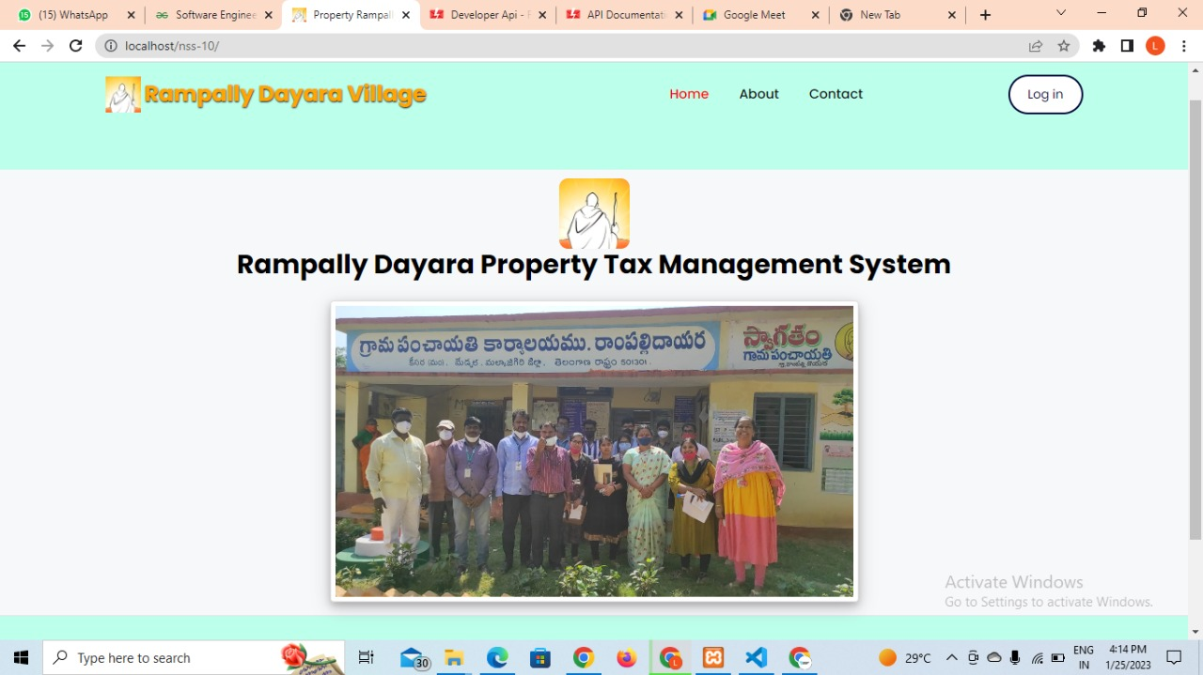

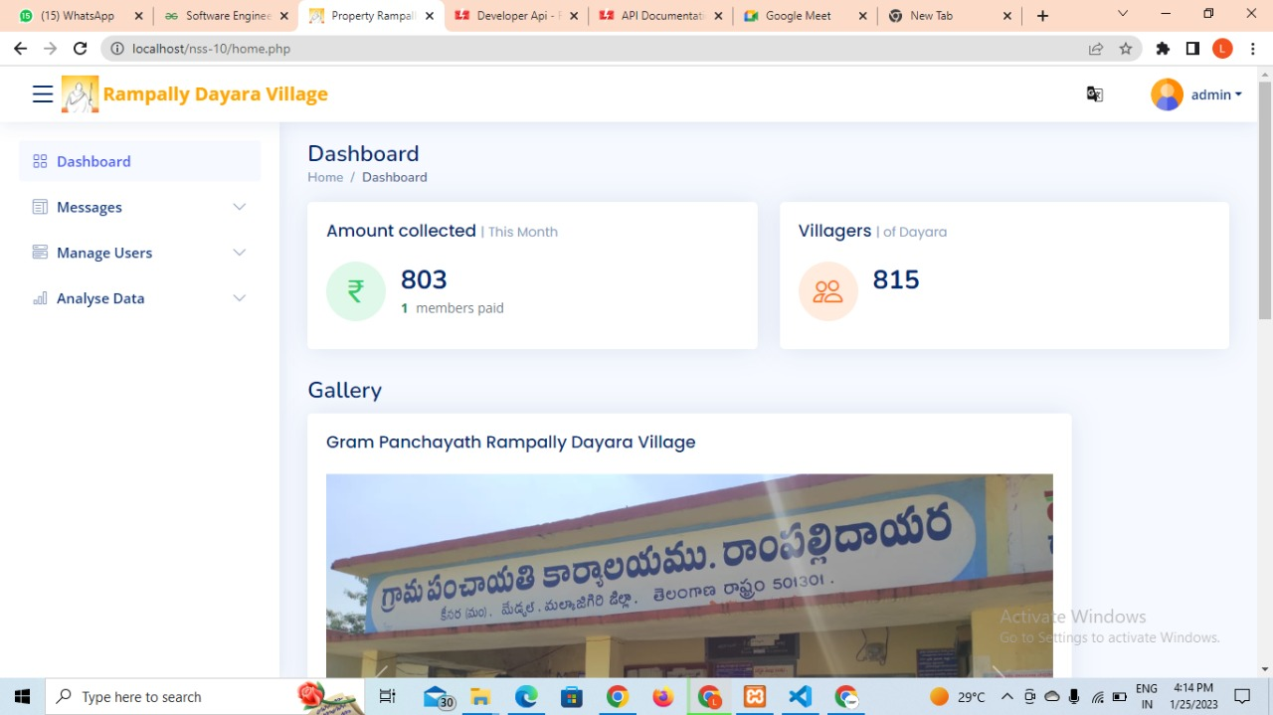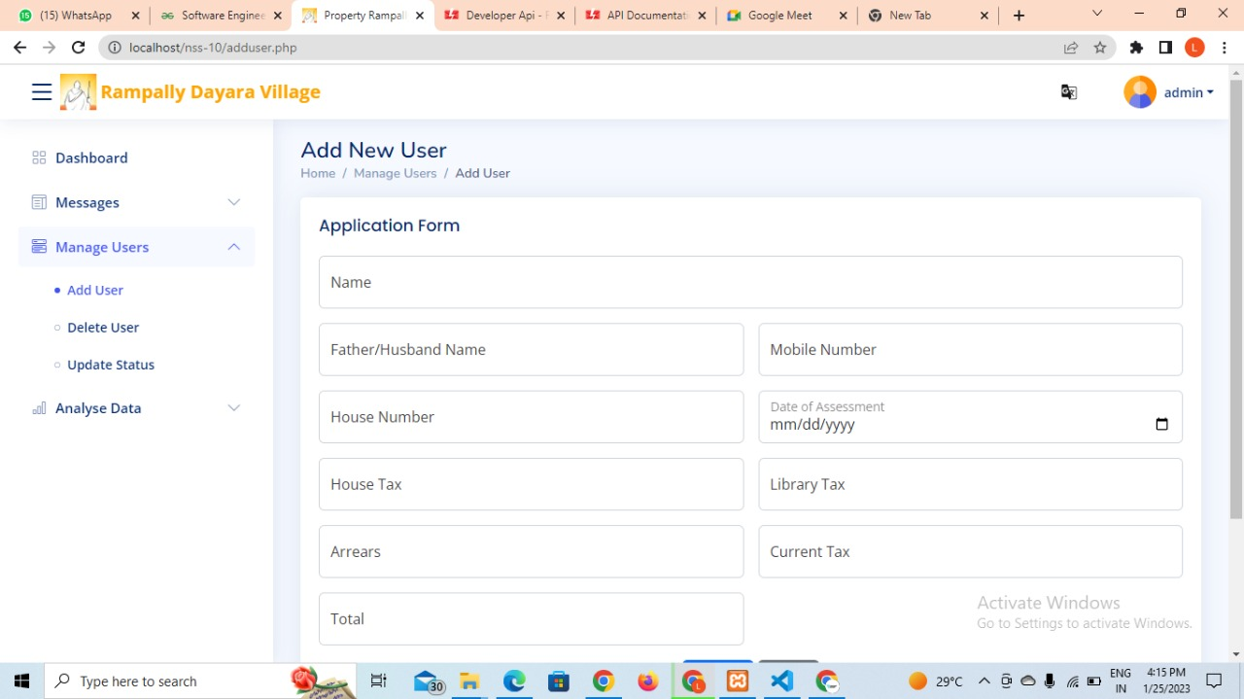

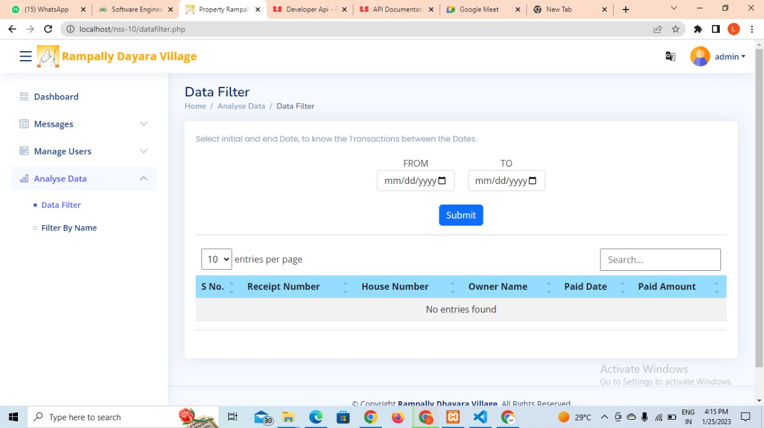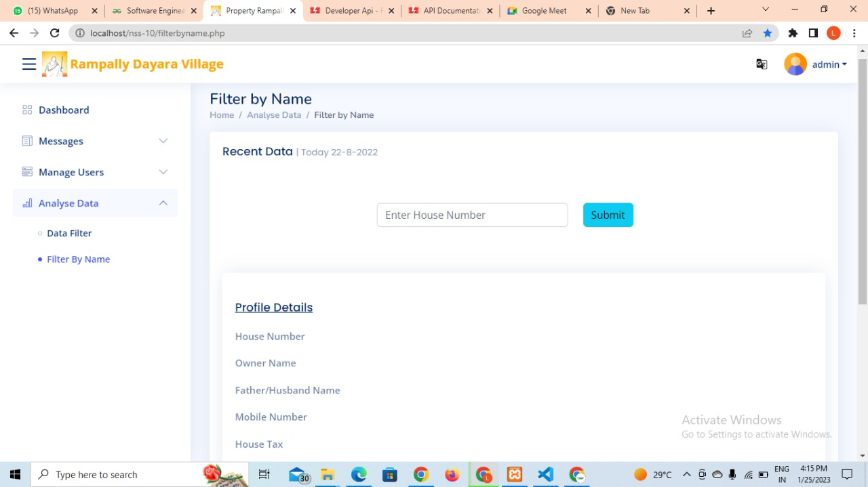

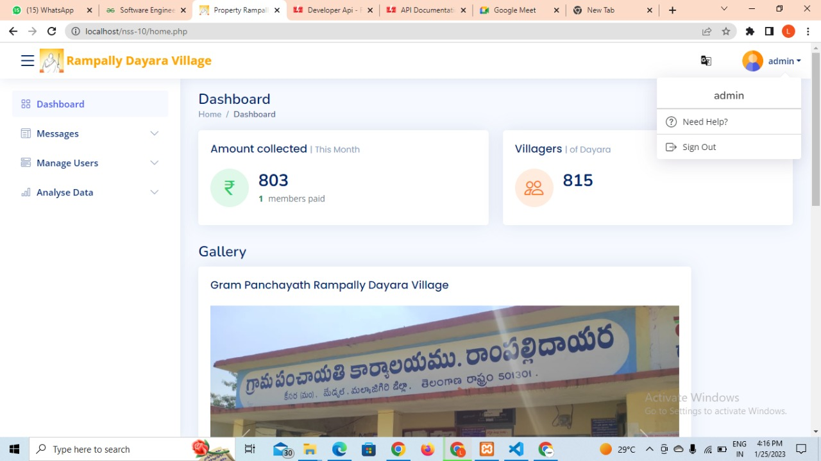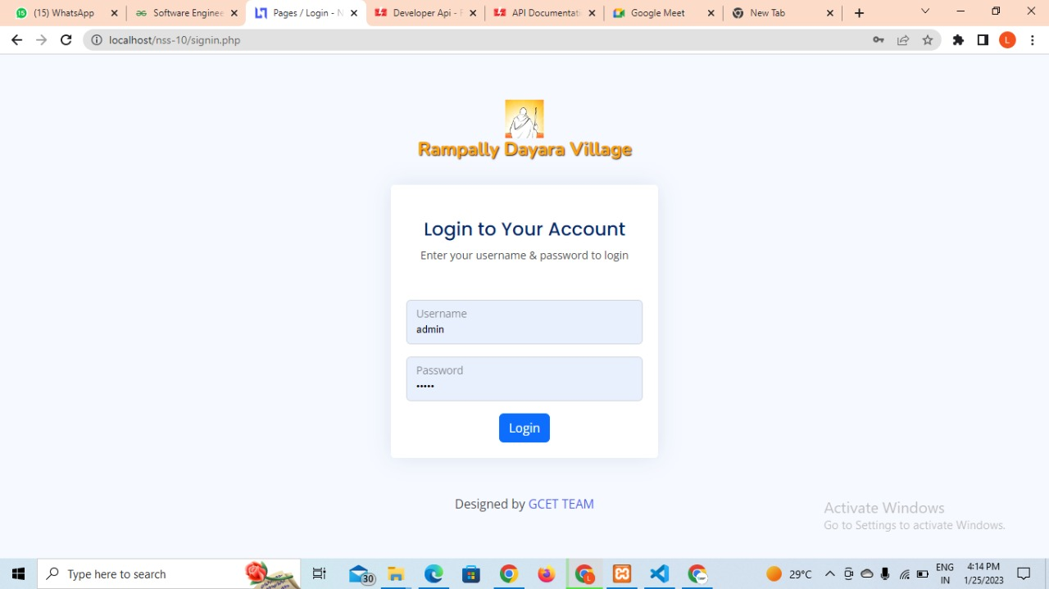

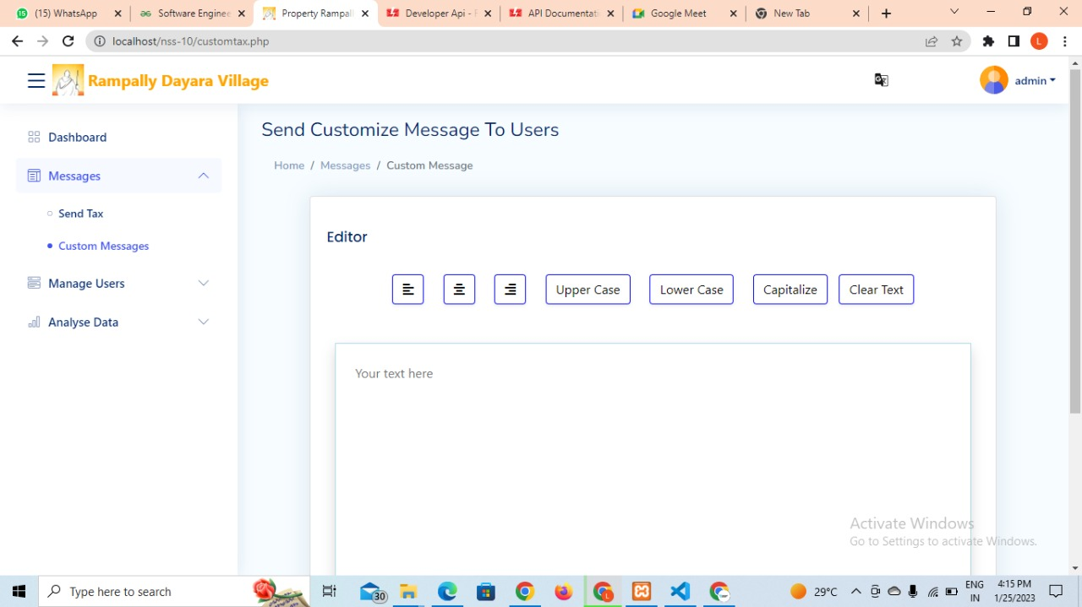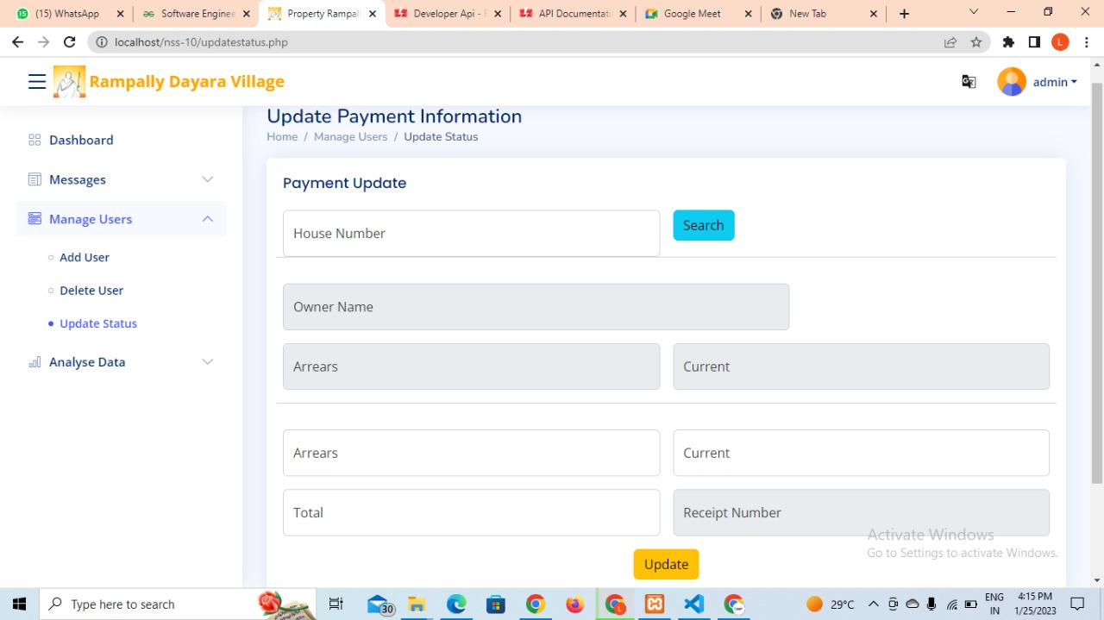

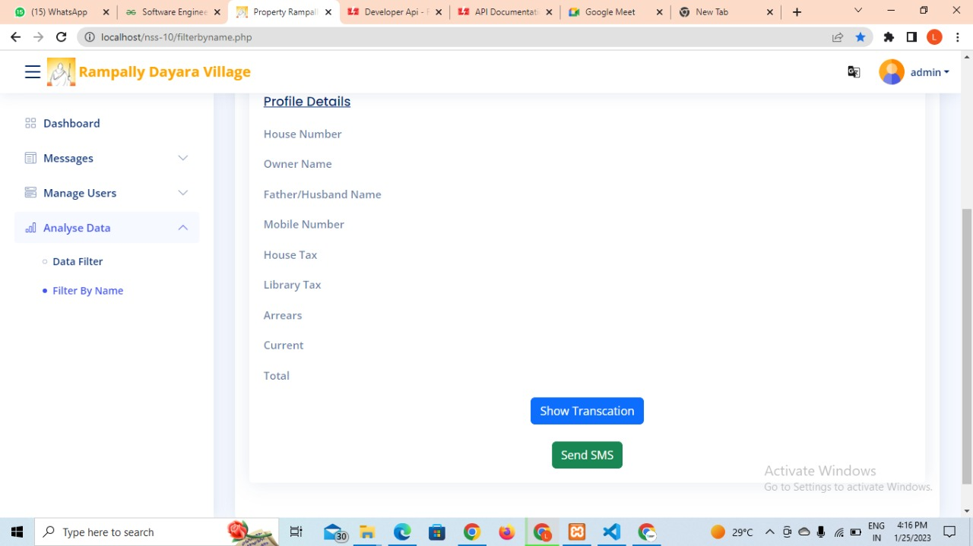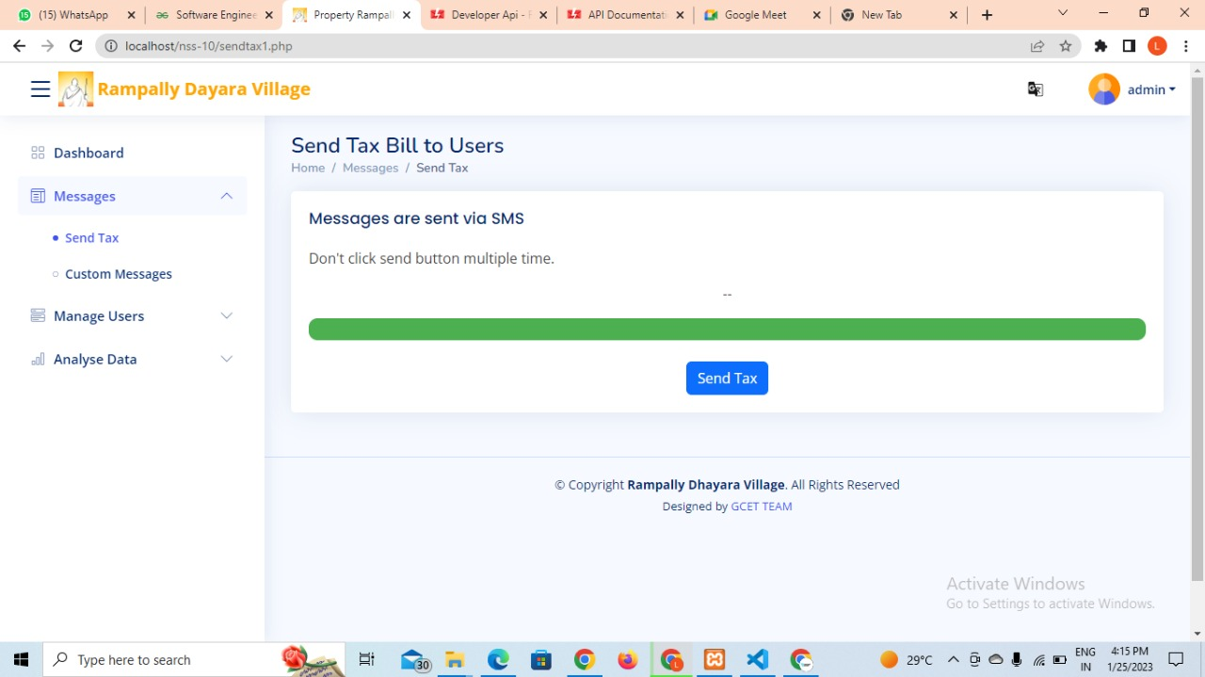

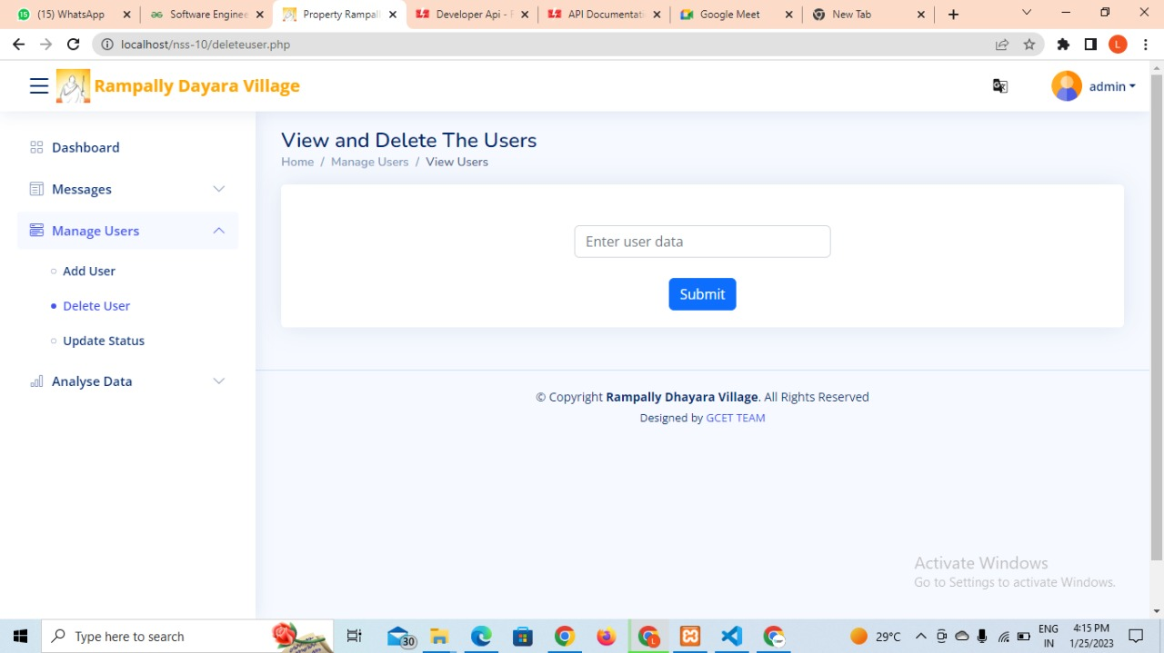

# 8. CONCLUSION

## 8.1 Conclusion:

## 

## “Rampally Dayara Property Tax Management” is a web application which is very much graceful and lively. The admin access will be given only to the panchayat sarpanch to avoid corruption of the data. This is a safe and easy way to maintain records of all taxpayers. Others cannot access the application without authentication as this is proprietary software.

## The technological revolution of the 21st century has made our planet a “global village”. This means that no matter where a person is on the planet, he/she can access anything that happens on the other side of the world through a simple click or tap of a screen. Our project aims to align with this ideology of a global village and empower taxpaying citizens with a transparent application which acts as a caretaker of their tax information. Our solution also saves a lot of time for both the officials handling the tax management process and the people abiding by the set tax rules.

## Having an application that can display tax information to users is especially useful when the citizens of that village must travel to and from their houses to the local govt office every time they want to find out about their tax information. Hence, having such a multifaceted tax management application is a significant upgrade over the existing system and helps the village of Rampally Dayara get up to speed with the “global village” ideology.

# 9. BIBLIOGRAPHY

# Agostini, C. and Tulayasethien, S., 2003. Tax Effects on Investment Location: Evidence from Foreign Direct Investment in the U.S. States. *SSRN Electronic Journal*, 5(7), pp.7-15.

# Agrawal, D., Fox, W. and Slemrod, J., 2015. Competition and Subnational Governments: Tax Competition, Competition in Urban Areas, and Education Competition. *National Tax Journal*, 68(3S), pp.701-734.

# Fernández, P. and Reinoso, L., 2003. Shareholder Value Creators and Shareholder Value Destroyers in USA. The year 2002. *SSRN Electronic Journal*.

# Tzougas, J., 2013. Tax Revenue, Private Investment and Real Income in Greece: Evidence from Multivariate Cointegration and Causality Analysis. *SSRN Electronic Journal*, 52(2), pp.3-6.

# Castagnetto, J., H. Raway, S. Schumann, C. Scollo, and D. Veliath (1999), *Professional PHP Programming*, Wrox Press.

# Andrew G. Bennett, "Using PHP For Interactive Web Bibliography," *Convergence* (December 2004).

# Bafna, Sumangla A. "Review on Study and Usage of MERN Stack for Web Development." *International Journal for Research in Applied Science and Engineering Technology* 10, no. 2 (February 28, 2022): 178–86. http://dx.doi.org/10.22214/ijraset.2022.40209.

# Peredo Valderrama, Rubén, and Iván Peredo Valderrama. "Herramienta de autoría para evaluaciones multimedia interactivas basadas en el modelo de componentes de React.js utilizables para la Educación 4.0." *Tecnología Educativa Revista CONAIC* 7, no. 1 (December 29, 2020): 78–85. http://dx.doi.org/10.32671/terc.v7i1.20.

# Kumar, Vipul. "SPIFFY SHIRTS E-COMMERCE STORE (CROSS PLATFORM APPLICATION)." *International journal of multidisciplinary advanced scientific research and innovation* 1, no. 10 (December 15, 2021): 295–301. http://dx.doi.org/10.53633/ijmasri.2021.1.10.008.

# Aldo, Dasril, Richo Richo, and Zainul Munir. "Aplikasi Pelayanan Pada Klinik Kemina Dental Care Berbasis React.Js dan Database NoSQL." *Informatika Mulawarman : Jurnal Ilmiah Ilmu Komputer* 16, no. 2 (October 19, 2021): 139. http://dx.doi.org/10.30872/jim.v16i2.6532.

# 10. APPENDIX

## Standardization guidelines

A standardisation activity has been defined within the Rampally Dayara Property Tax Management Application, to ensure that the Web-related access technologies will be propagated to the official standard bodies. The detailed objectives of this activity concern:

* the identification and assessment of the international state of the art with regards to current, on-going and anticipated future standardisation activities;
* the identification of requirements for Web accessibility and development of recommendations;
* the dissemination of the results to the relevant national, European and International standardisation bodies.

To achieve these objectives a four-phase approach has been adopted: *data collection*, *data analysis*, *consolidation & recommendations*, and *dissemination* (see Figure 0).

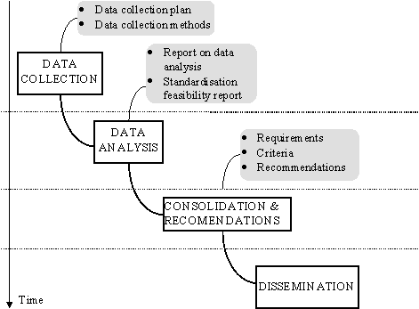

Figure 0 - Phases of the project